**FOSTER CARE**

**A Guideline for Success**

Kern County Animal Services Cat Foster

3951 Fruitvale Ave Bakersfield, CA 93308

Email: [catfoster@kerncounty.com](mailto:catfoster@kerncounty.com)

FaceBook Group: KCAS Cat Fosters

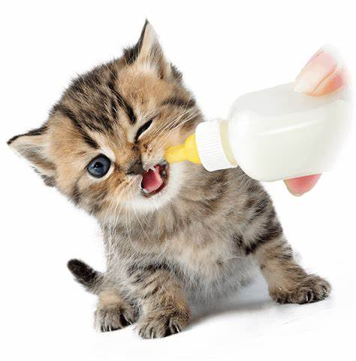

**Veterinary Care** (page 19)

* Routine Veterinary Care
* Scheduling Rechecks
* How to Schedule Appointment/Recheck
* Vaccines

**Bite Protocol** (page 20-21)

* If Bite Occurs
* If Bite Results in Injury
* Bite Assessment
* Wound Care
* How to Prevent Bite

**FAQS** (page 22-23)

**Resources** (page 24)

**Ready for Adoption** (page 25)

* How do Pets in Foster Get Adopted?

**Emergency Health Sheet** (page 3)

**Basic Fostering Needs** (page 4-5)

**Get Ready** (page 6-8)

* What Does KCAS Supply?
* What are my responsibilities?
* Preparing the Room
* Necessary Supplies
* Protecting Your Personal Animals

**Kitten Care** (page 9-14)

* Bottle Baby Care & Feeding
* How To Bottle Feed
* Transitional Feeding
* Feline Developmental Stages
* How Much to Feed

**Socializing Kittens** (page 15)

**Maintaining Foster Health** (pages 16-18)

* Diarrhea
* Constipation
* Vomiting
* Nasal Discharge
* Ocular Discharge
* Fleas
* Lice
* Ear Mites
* Ringworm

Table of Contents

NO MATTER WHAT LEVEL OF EMERGENCY, IT IS IMPERATIVE THAT YOU BE AS DETAILED AS POSSIBLE & ADD THE ANIMAL ID NUMBER IN YOUR DESCRPTION SO THAT OUR STAFF CAN BEST ASSIST YOU.

If you have non–emergency questions about the health of your foster animal, please email catfoster@kerncounty.com and give our foster team 24 hours to respond. If an emergency should arise **during regular hours of operation,** and you cannot get a hold our Foster Team, please come directly to the shelter. If your foster animal has an emergency that occurs outside the normal hours of operation, please call the emergency # 661-321-6117.

**Kern County Animal Services Department must approve any/all treatment for foster pets.**

**What To Do If…**

Please review the information below to determine what type of emergency and what to do.

**Mild: send an email to** [**CATFOSTER@KERNCOUNTY.COM**](mailto:CATFOSTER@KERNCOUNTY.COM)

* One episode of vomiting or diarrhea
* Sneezing
* Watery eyes
* Ate something: toys, nipples, etc.
* Broken nail
* Skin irritation
* Visible worm in stool
* Fleas & Ticks

**Moderate: Send an email & Schedule a Foster Recheck on WAITWHILE**

* Vomiting for more than 24 hours or more than once/twice daily
* Cut/puncture wound/abscess
* Low appetite/not eating
* Green nasal/eye discharge
* Hair loss
* Sucked on by litter mates
* Limping
* Diarrhea for more than 24 hours
* Straining to urinate/blood in urine
* Chewed or removed sutures or staples
* No stool for more than 48 hours
* Milk coming out of nose
* Sounds congested/wheezing

**Emergency: Immediate Phone Call to Emergency Line (661) 321-6117**

* Fading kitten syndrome
* Unresponsive/lethargic
* Having trouble breathing
* Seizure/disoriented
* Unable to stand or walk
* Continuous diarrhea/vomiting
* Bleeding (nose, urine, or stool)
* Injured (stepped on, smashed, etc.)
* Ingested a dangerous item
* Cat bite/broke skin

***Dear Foster Family:***

Sincerely,

Kern County Animal Services

Foster Team

We would like to take this opportunity to thank you for your giving spirit toward the animals in our shelter by becoming a foster family. Our special foster families provide a safe and healthy environment for young animals to be able to grow; and injured, sick, or under-socialized animals a place to heal. Kittens under the age of 8 weeks are medically and legally unable to stay in the shelter on their own. Since the inception of our Foster Care program, special participants, just like you, have saved thousands of dogs and cats, which would have otherwise been euthanized.

We have developed this manual to assist you with guidance and helpful tips to ensure the success for the duration of your foster animal’s stay in your home.

Fostering can be time consuming and quite a bit of work, but it is also a very rewarding experience. Your nurturing helps these kittens grow from helpless little beings into well-adjusted family pets. You also have the enjoyment of their company during a fun period of their lives without the responsibility of lifetime care. But most importantly, you are saving their lives.

Fostering requires a flexible schedule and a personal commitment to the kittens; they are dependent on you for everything. During a typical day, you will need to allow for enough time to give them fresh food and water *at least* twice a day (depending on age.) You will also need to clean their litter boxes at least twice a day. You will have to clean/bathe them, if necessary; medicate them if they become sick; monitor weight (if they are very young and/or sickly); and transport them back and forth for vaccinations, and other medical care. Don’t forget to save lots of time for playing and cuddling!

Please understand that we try to place the kittens in foster care as soon as possible to minimize their stay in a stressful situation. Therefore, the kittens will be sent out with the volunteers who respond first to our phone calls. Kittens need to be returned every two weeks (or as directed) for medical examination by our vet staff. When the kitten(s) reach their 2-pound weight goal they will be available for you to adopt. If you are not adopting be prepared to leave them at the shelter.

If the requirements included in the following section do not work well with your current schedule, please let us know. We can help you find a foster situation that will work better for your lifestyle.

***BASIC FOSTERING NEEDS***

***TIME***

Are you able to devote the required time daily and weekly to your foster animal?

Are you able to bring foster animals to the shelter for vaccinations and wellness exams every 2-3 weeks?

Are you able to contact KCAS or bring foster animals to an emergency care facility quickly in an emergency?



**YES NO**

**YES NO**

**YES NO**



***SPACE***

Are you able to separate your foster animals from your household pets?

Are you able to handle cleaning procedures such as washing hands after every encounter and

cleaning/disinfecting the animals’ quarters routinely?

Are you able to handle any potential home damage (carpet, clothing, and/or furniture) associated with animals?

**YES NO**

**YES NO**

**YES NO**



**YES NO**

**YES NO**

**YES NO**

***CARE***

Are you prepared to handle sickness or possible death of your foster animal?

Are you able to emotionally handle letting go of the foster animal after becoming attached once their foster period is over?

Are you able to handle the potential of foster animals carrying illness that could affect your household animals/family?

***What does KCAS provide to its Fosters?***

* Resources: medical, and general assistance with caring for your foster cat/kittens.
* Supplies:
* Carriers (cats must be transported in carriers at all times)
* Food (Only feed the kittens food provided by KCAS)
* Cat Litter
* Heating Source (as available)
* Towels, Blankets, and Newspaper (if requested)
* All medical care for the cat/kittens as deemed appropriate by our medical staff.

***What are my responsibilities as a foster?***

* Provide a safe, clean, caring environment.
* Provide food, water, toys/enrichment, and shelter.
* Provide exercise and socialization as appropriate.
* Monitor any medical and/or behavioral problems.
* Transport to/from any necessary appointments at our shelter.
* Carefully read all documents & carefully follow all instructions that KCAS provides.

**Getting yourself ready……………**

**Everything you need to care for your foster animal, including vet care, is provided free of charge.**

**KCAS does not provide litter boxes or food/ water bowls.**

***Preparing A Room for Fostering***

When considering fostering animals, decide which room in your house works best. Due to the general area, a bathroom often works well in securing the animals is a safe room. When preparing any room in your house for foster animals the following guidelines will help you:

* A space where the temperature can be controlled.
* A space that can be disinfected using a mild bleach solution of 1 part bleach & 32 parts water.
* A space separate from other household pets.
* A space that can withstand messes such as spilt water or food, vomit, urine, feces, etc.
* A space where any electrical outlets or wires are blocked.
* A space where no breakable items are within reach of the foster animal.
* A space with no small items that can be easily swallowed.
* A space with windows secured by either being closed or with a secure screen.
* A space with secured appliances; or if in a bathroom a closed toilet lid to prevent drowning.

***Necessary Supplies***

* **CARRIER:** You will need to bring an appropriately sized carrier to transport the fosters home and to bring them back and forth for medical appointments. We have only a very limited supply of small carriers to loan out.
* **FOOD:** Please use only the food provided by KCAS. You will be supplied with dry kibble and canned food. Any change at all in diets must first be approved by our veterinarian. A mother cat is given the same dry and canned food. For orphaned newborns who need to be bottle-fed, we will provide you with kitten milk replacement formula and bottle(s).
* **CAT LITTER:** Please use only the cat litter supplied by KCAS. Clumping litter may be dangerous if ingested by kittens and is not recommended.
* **WATER BOWL:** Should be ceramic/porcelain or stainless steel but NOT plastic, as plastic is difficult to disinfect due to its porosity. Heavier is better so it won’t tip over. We cannot currently supply bowls.
* **FOOD BOWLS:** One bowl for the entire litter for the eat-at-will dry kitten food and another bowl for the canned food. It is usually best to have a separate bowl/dish for each kitten to eat canned food from, to ensure that each gets its fair share. Inevitably, there is a food bully in the litter that may crowd out a less assertive sibling.
* **HEATING DEVICES**: Heating pads (NO AUTO SHUT-OFF), heating discs, rice socks, hot water bottles. From 3 – 4 weeks of age and older, the floor temperature of the kittens’ environment should be 70 – 75 degrees F. But for the younger ones, their sleeping environment needs to be 85 – 90 degrees F. In order to maintain this temperature, you will need some type of heating device. We will provide you with rice filled warming pads, and blankets to wrap them. We encourage you to look around in thrift stores and garage sales for the old-fashioned heating pads **without** the Auto-Off safety feature. Heating pads should always be on the LOW setting (NEVER on Medium or High). Wrap both the electrical cord and heating pad itself with a thin blanket or towel to safeguard the kittens. They should NEVER be placed directly on a heating pad as this could cause burns. Always make sure there is a large enough area for the kittens to move off the heating pad if they get too warm.
* **SCALE:** We are not yet able to provide scales to our volunteers. If you have a postal or food scale at home, this would be very helpful in monitoring the weight gain of very young kittens. This is particularly critical for sickly kittens, newborn kittens and those up to 4 weeks old. A weight gain of 3 to 4 ounces (84 to 113 grams) each week, usually indicates the very young kittens are doing well.
* **TOWELS, BLANKETS & NEWSPAPER:** We have ample supplies of all of these. Let us know when you are picking up kittens if you need any of these items, we will gladly provide you with some.

**Getting yourself ready……………**



***Protecting Your Personal Animals***

First and foremost, we want to protect the health of both your personal pets and the fosters. We need to be concerned about your pets’ introducing diseases to the foster animal as well as that animal introducing diseases to your pets. Foster animals are given a medical exam/screening before going home with you, but we cannot guarantee that they are not carrying something contagious to you and/or your animals.

As a precaution, fosters MUST be kept separated from your household pets for the safety of both. KCAS is not responsible for the health of your personal pets. Having a totally separate room for the fosters would be ideal, but there should be absolutely no sharing of food and water bowls, litter boxes, and toys. Good personal hygiene of washing hands with soap and water should be practiced regularly, both before and after contact, with foster kittens. As thorough and careful as we try to be in our examinations of the fosters before sending them out, there is still a real risk of disease transmission.

Cleaning between litters is another precaution against spreading disease. After a foster is returned to KCAS, the fostering room will need to be sanitized before another foster is brought home. All surfaces should be disinfected with a mild bleach solution (1 ounce bleach to 1 quart of water). Any item that cannot be washed in hot water or sprayed with the bleach solution should be disposed of.

**Getting yourself ready……………**

**Kitten Care**

**\***CHILLING is the #1 DANGER to newborns. Always have a layer of bedding between kittens and heating source.Heating pads should **always be on LOW setting.** Make sure kittens have a cooler place to move to if they get too warm.

**Feeding:**

1. DO NOT USE COW’S MILK!Use only the formula provided to you by the shelter. If you are running low, you can pick up more during business hours.
2. Make sure the kitten is warm before feeding. If necessary, wrap it in a blanket to keep warm during feeding. Feeding formula to a cold kitten can cause serious digestive problems.
3. Be sure that all bottles and nipples are clean before using. Regular nipples will need to have a hole punctured or cut, miracle nipples will not.
4. To make kitten formula:mix 1 Tablespoon powdered formula with 2 Tablespoons warm water. Do not mix more than can be used in a 24-hour period. The formula will last 24 hours once it has been reconstituted and should be kept refrigerated. Fill the bottle with formula and warm the formula by placing the bottle in a mug of very hot water. The milk should be approximately body temperature, around 95 to 100 degrees. Test the temperature of the milk on your forearm before feeding your kitten. Test the nipple to ensure that the milk is flowing through the nipple correctly. It should not drip when held upside down but should drip given a small amount of pressure on the bottle.
5. Place the kitten prone (belly down, NEVER on Its back)on a towel or blanket. Without raising the kitten’s head, place the kitten’s head gently on your palm and guide the nipple into its mouth. The kitten should start nursing right away. Be sure to tilt the bottle up slightly to prevent the kitten from inhaling too much air.

*DO NOT allow kittens to nurse on one another. The urge to nurse is very strong. In the absence of their mother, some kittens will nurse on the extremities and/or genitalia of their littermates. This can cause potentially life-threatening injuries. Kittens demonstrating this behavior should be moved to a separate area (with heating pad, etc.) This problem usually peaks by 2-3 weeks of age.

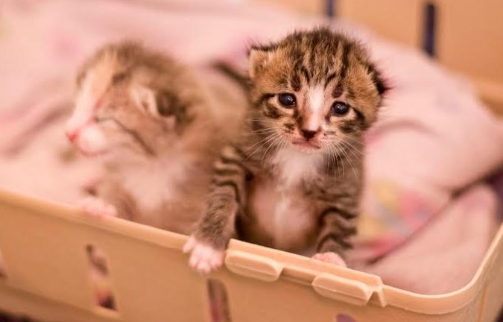

**Bottle Baby Care & Feeding:**

**Kitten Care**

1. If the kitten does not start nursing right away, or if it seems to be having trouble getting the milk, check the nipple again. Kittens who have only recently lost their mother can struggle to take to the bottle. It may be helpful to stroke his head gently or pet his back to start his nursing reflexes. Pulling lightly on the bottle or twisting the nipple while in the kitten’s mouth can also encourage the kitten to suckle.
2. **NEVER SQUEEZE THE BOTTLE TO FORCE MILK DOWN THE KITTEN’S THROAT!** This could force the formula into thelungs and cause pneumonia and possible death.
3. After feeding, your kitten will need to be burped. This can be done by holding the kitten against your shoulder and gently massaging or patting its back.
4. Do not underfeed or overfeed your kitten. To find out how much and how frequently your kitten should be fed, please refer to pages 9-11.
5. After feeding, each kitten will need manual stimulation by you to encourage urination and defecation. Lightly rub anus and genital area with a warm washcloth or dampened paper towel. Kittens should urinate at every meal but may not “poop” as often. If kittens are refusing to eat, you can also try “pottying” them before continuing to feed as they may still be full from their previous feeding.
6. Kittens will sleep after feedings, so they should be placed in a warm area to rest.

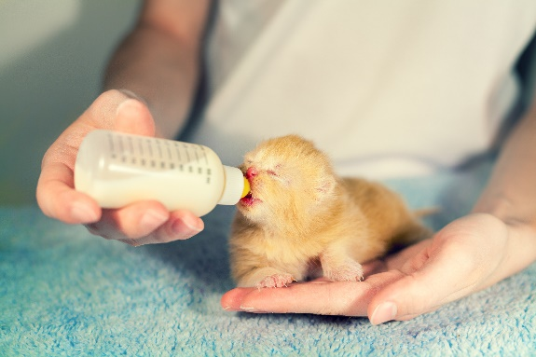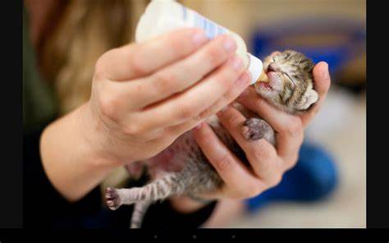

Correct feeding position

DO NOT feed kittens on their backs – it can lead to milk in the lungs!

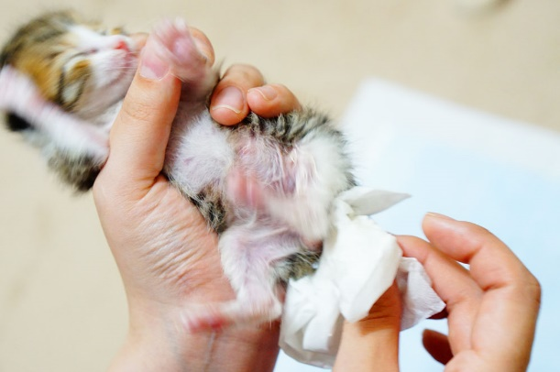

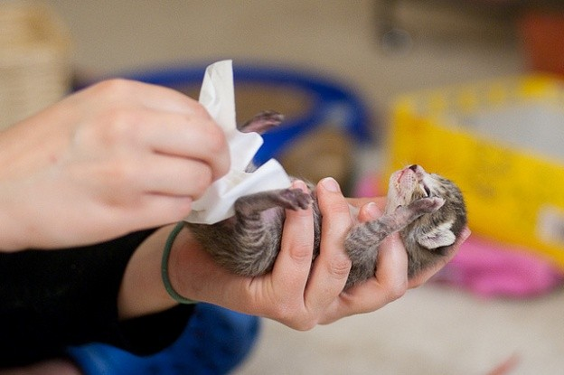

Stimulation to urinate and defecate

**Kitten Care**

Transitional kittens are kittens that are being weaned off bottle-feeding to eventually be able to eat solid foods.

**Transitional Feeding:**

1. Start by serving the formula in a shallow bowl. Dip one fingertip (or the bottle the kitten is used to nursing from) into the liquid; let the kitten lick it, then guide him by moving your finger down into the bowl. **Do not force the kitten to drink.** This concept is easy for some kittens to grasp but not for all, so be patient. Bottle-feeding may still be required as the kitten learns to eat from the bowl. You can help with the gradual transition by always offering the bowl first and then the bottle.
2. When the kitten is lapping up the formula liquid well, it is time to make a gruel. This is a mixture of canned kitten food and formula. As the kitten gets accustomed to eating, gradually decrease the amount of formula, while slowly increasing the amount of canned kitten food.
3. If your kitten seems uninterested in the canned kitten food and formula gruel, the veterinary staff may suggest that another type of canned food be used instead to help encourage eating. But **DO NOT** try any food without the veterinary staff’s approval. Also try heating up the gruel in the microwave for 8-10 seconds. Give the gruel a good stir and check temperature before feeding to your kitten. The gruel should only be warm to touch.
4. A kitten should be completely weaned off of the formula and bottle by six weeks of age and eating only canned food. The warmed, canned food should be offered to them 3 to 4 times a day. It is better to offer them smaller quantities more often than larger quantities less frequently. Discard any uneaten food. Make sure they have clean, fresh water at all times.
5. If you have a litter of more than one kitten, it is a good idea to serve their canned food in separate bowls.Often larger, stronger kittens will push siblings away to get more food. Fighting for food can set back a kitten’s weight gain very quickly. You should monitor their eating to avoid “food bullies.”
6. From 6 to 7 weeks of age, kittens can be introduced to dry kitten food. A bowl of this may be left out for them to free feed throughout the day.

**Kitten Care**

**0 – 1 Week Old**

* Bottle Feeding: up to ½ Tbsp. (8ml) formula every 2 – 3 hours (about 8 - 10 feedings per day).
* Temperature in bedding area should be 85-90°F. CHILLING is the #1 DANGER to newborns. Kittens must have an external heat source (rice sock, heating pad etc.) at all times. Your body heat is not warm enough.Place heating device on half their bedding and cover with a layer of bedding. **Always have a layer of bedding between kittens and heating pad/disc/sock.** Heating pads should **always be on LOW setting.** Make sure the kittens have a cooler place to move to if they get too warm.
* Weight will be about 4 ounces. Will sleep 90% of the time. Newborns are deaf & blind & rely entirely on smell. Handle minimally.
* If there is a mom cat, make sure each kitten is nursing. A lot of crying and activity could indicate a problem with milk flow or availability. Newborns can nurse from Mom for up to 45 minutes.

**1 – 2 Weeks Old**

* Bottle Feeding: up to ¾ Tbsp. (12ml) formula every 2 - 3 hours (about 8 - 10 feedings per day)
* Temperature in bedding area should be 80 - 85°F. Kittens will continue to need an external heat source until at least 4 weeks old.
* Weight will be about 7 ounces. Ear canals open between 5 -- 8 days old. Eyes open around 8 -- 14days old. Initially, eyes always appear dark blue. Vision will be blurry. Healthy kittens will be round and warm, with pink skin. Healthy kittens seldom cry.

**2 – 3 Weeks Old**

* Bottle Feeding: up to 1 Tbsp. (15ml) formula every 3 - 4 hours (about 6 - 8 feedings per day).
* Temperature in bedding area should be 75 - 80°F. Make sure kittens have a cooler place to move to if they get too warm.
* Weight will be about 10 ounces. Ears will become erect, and canals open completely. Kittens will start to crawl and stand between 18 - 21 days old. Teeth start to become more noticeable.
* Play behavior begins. Start of socialization phase. Increase handling to get them used to human contact. It is important not to expose them to anything frightening. Children may seem intimidating and should be closely supervised.
* If there is a mother cat, she will spend more time outside the nest.

**Feline Developmental Stages:**

**Kitten Care**

**3 – 4 weeks old**

* Bottle Feeding: up to 1 ½ Tbsp (23ml) formula every 4 hours (about 4 feedings per day).
* Towards 4 weeks of age, may start to lap formula from a bowl. **Middle of the night feedings no longer needed,** unless sickly and not thriving.
* Temperature in the bedding area should be 70 - 75°F.
* Weight will be around 13 ounces. Permanent adult eye color will start to appear. Self-grooming begins. Vision continues to improve
* Litter box training may begin as early as 3 weeks. Place kitten in shallow litter box after feedings. Hold onto kitten’s front paw gently and “paw” at the litter. Sometimes helps to put some feces they made earlier in the box, so they make the association. Most of time, they need no training at all. **Do NOT use clumping litter.** It can be **very harmful** to kittens if ingested.

**4 – 5 weeks old**

* Weaning bottle babies: up to 4 Tbsp. formula every 5 - 6 hours (about 3 feedings per day).
* Wean gradually by offering them gruel: warm canned food mixed with warm water or formula. Gradually thicken the gruel. It may take a few feedings for them to catch on. If they show absolutely no interest, wait a few days and try again. If there is a mom cat, she will start to wean them by discouraging nursing.
* Litter box training may begin as early as 3 weeks but definitely by 4 weeks old. Place kitten in shallow litter box after feedings. Hold onto kitten’s front paw gently and “paw” at the litter. Sometimes helps to put some feces they made earlier in the box, so they make the association. Most of time, they need no training at all. **Do NOT use clumping litter.** It can be **very harmful** to kittens if ingested.

**5 – 6 weeks old**

* Feed gruel 4 times a day. Thicken gruel gradually. Introduce dry food and water closer to 6 weeks of age.
* If there is a mom cat, the kittens may start eating her food.
* Weight will be between 1 pound and 1 1/2 pounds. Kittens start to roam. Keep them well supervised. Play and interact with them as often as possible. Get them accustomed to household noises (vacuum, TV, dishwasher, etc.).

**Kitten Care**

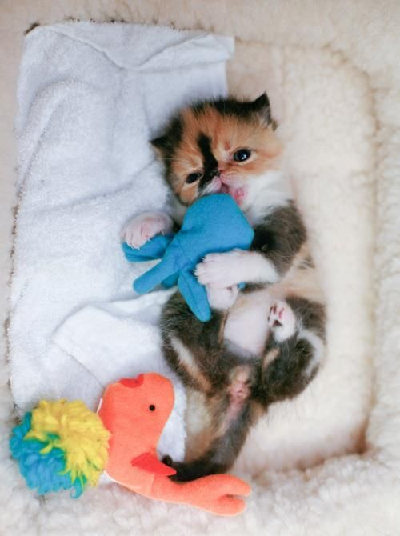

**6 – 7 weeks old**

* Kittens should be eating both canned and dry food. They will eat small amounts at frequent intervals throughout the day. Make sure dry food and water are available at all times. Offer warm canned food 3 – 4 times per day.
* Make sure room is safe. Kittens are now climbing and jumping. Litter boxes need to be easily accessible and visible to minimize accidents.
* Weight will be around 1 1/2 pounds. Kittens are now “mini-cats”. They will groom themselves, play and use scratching posts.

**7 – 8 weeks old**

* Offer warm canned food 3 times per day. Have dry food and water available at all times.
* Make sure room is safe. Kittens are now climbing and jumping. Litter boxes need to be easily accessible and visible to minimize accidents. Weight will be around 1 3/4 pounds. Continue playing and socializing with the kittens.

**8 weeks +**

* Offer warm canned food 2 times per day. Have dry food and water available at all times.
* Make sure room is safe. Kittens are now climbing and jumping. Litter boxes need to be easily accessible and visible to minimize accidents.
* Kittens should be 2 pounds and ready to come back to KCAS for adoption. Generally, the entire litter comes back together.

**Socializing Kittens**

**Part of your job is to convince the kittens that humans are kind and loving.**

* Outgoing, friendly kittens can be cuddled and played with freely, after spending a day or so to accustom themselves to a comfy bed in a quiet room.
* Shy kittens will need more encouragement. Try sitting on the floor with a kitten held against your chest, supported underneath, and facing outwards, so it can’t see how big and scary you are. Stroke the kitten and speak gently for about 30 seconds, then put the kitten down before it starts squirming. You want this to be a pleasant experience. The kitten may not be impressed, but if you cuddle them often enough, they will learn to love it.

**“Feral kittens” and “Semi-Feral” kittens:**

* These kittens are a special challenge to socialize. The earlier feral kittens are separated from their mother, the more likely they are to adapt to people. Even at 6 weeks, feral kittens can act like little tiger cubs.
* If your kittens are fearful and run away when you approach, try sitting or lying quietly on the floor near them and let them come to you.
* Spend time quietly in their presence to get them accustomed to your company.
* Stroke them and talk to them gently while they are eating to further reinforce positive associations.
* Frequently, it is faster and easier to bring a feral kitten around when it is fostered as a singleton. When they have the company of another kitten, they will choose that kitten over you.
* There is no such thing as a “bad” kitten. Even if your litter doesn’t enjoy being held and cuddled, if they will tolerate being stroked and don’t cower under the couch, they will make someone a wonderful pet. Not everyone wants an affectionate lap-cat. Many people prefer cats who are more independent and somewhat aloof companions.
* Ask our foster care staff for more socialization tips and tricks.

**Maintaining Foster Health**

Foster kittens are given an exam prior to going out to foster and must be returned for checkups every two to three weeks (Or as directed by medical staff). However, they can, and do, often break with signs of illness once in your home. It is critical to monitor them closely and to contact us if you notice any signs of illness. (See the chart on page 2 to decide what to do)

***Diarrhea:***

Diarrhea is extremely common in kittens and can have a variety of causes from dietary changes to parasites.

There are three types of cat stool: normal, soft formed, and diarrhea. Normal stool is firm and well-shaped. Soft stool is toothpaste-like in consistency and diarrhea is completely liquid.

When you first notice soft stool, see the chart on page 2 to decide what to do. Treatment will most likely entail a combination of oral medications we will give you to administer at home. Monitor the kitten closely, as dehydration is a common consequence of diarrhea and can become serious, even life threatening, very quickly.

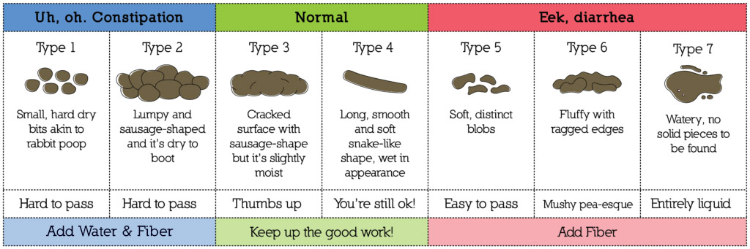

***Constipation:***

Constipation is common in bottle babies and young kittens. Monitor your kitten closely if they have not defecated (pooped) to ensure that they are eating, bright, playful, and urinating. As long as they seem well otherwise, it is okay to wait up to three days for a bowel movement. If more than three days have passed, please make an online medical appointment.

***Vomiting:***

Sometimes kittens can vomit due to eating too rapidly. Observe your kitten and if this is the case, offer smaller portions more frequently rather than one large meal all at once. If your kitten vomits more than 2 times, please make an online medical appointment.

**Maintaining Foster Health**

***Upper Respiratory Infections (URI):***

Upper Respiratory Infections are cold or flu like symptoms and are extremely common in street kittens.

Symptoms:

* **Sneezing/nasal discharge:** Occasional sneezing is common in kittens. However, if it becomes more frequent or if it progresses to having nasal discharge (snot), this is a sign of a URI and needs to be address by shelter medical staff. Please make an online medical appointment. Treatment typically involves a course of oral antibiotics.
* **Ocular discharge:** Another common symptom of a URI is ocular/eye discharge. Eye discharge can range from mild to severe. Please make an online medical appointment. Treatment will typically consist of an antibiotic eye drop or ointment.

**URI is very common and treatable but can become serious quickly in young kittens. When in doubt, make a medical recheck online appointment. KCAS is responsible for all medical care, do not take your foster kittens to your personal Vet.**

**Maintaining Foster Health**

***Skin Parasites:***

**Fleas:** Most of the kittens we receive in our foster program are born outdoors, so may come to us with external parasites such as fleas. Kittens are examined prior to being sent out to foster and treated if fleas are seen. However, if you notice live fleas on your kittens more than 24 hours after taking them home, please make an online medical appointment to arrange for further treatment. Never treat the kittens yourself as many of the flea products are toxic to such small animals.

**Lice:** Occasionally, kittens will come into the shelter with lice. If we are able to see the lice infestation when they are brought in, we will treat the kittens in the shelter and not send them out. However, sometimes these infections are difficult to detect until they are fairly

advanced, which may be once the kitten has been in your home for a few days or even weeks. You will not see the adult lice; you’ll just notice white dots along the kitten’s hair. The dots, which are nits, will not come off if you brush the kitten, {as compared to dandruff, which is easily removed}. Lice are not contagious to you, as they are species specific.

**Ear mites:** Kittens with ear mites will scratch at their ears and shake their heads. Inside the ear, the canal is often filled with a dark debris that looks like coffee grounds.

**Ringworm:** Ringworm is a highly contagious fungal skin disease, most commonly found on the head and extremities in kittens and is transmissible to humans. Ringworm is treatable but is something that needs to be caught at onset because of how contagious it is and how difficult it can be to eradicate from your home. Ringworm causes patchy hair loss and the skin revealed often appears rough and scaly. The spot will usually get larger and additional spots often appear within a week or so.

**VETERINARY CARE**

***Routine Veterinary Care:***

Routine veterinary care is provided by the Medical Team at Kern County Animal Services Department during normal business hours. The Foster Team will work directly with the shelter’s Medical Team to manage the health and well-being of each foster pet or litter. After hours, one of the shelter’s Supervisors will take calls when emergencies arise. In the event of an emergency after hours, the Supervisor will instruct the foster parent or family of the appropriate steps to take.

Kern County Animal Services Department has a policy that we will not reimburse individuals for vet bills for foster animals when taken for veterinary care outside of that which is pre-authorized by the Kern County Animal Services Department.

***Scheduling Rechecks:***

Foster animal(s) are required to return to the shelter every two-three weeks for vaccinations, deworming and general exams unless otherwise discussed. All rechecks require an appointment, which can be scheduled on Waitwhile.

Recheck times are as follows:

* Monday 10 AM to 4 PM
* Tuesday 10 AM to 4 PM
* Wednesday 1 PM to 7 PM
* Thursday 10 AM to 4 PM
* Friday 10 AM to 4 PM

**If for any reason you are unable to**

**keep your scheduled appointment, please email the Foster Team or reschedule on waitwhile.**

***Vaccines:***

Cats receive vaccinations every two-three weeks from the time they are 4 weeks of age until they are 16 weeks or unless otherwise directed by our veterinarians. Animals 12 weeks and older receive a Rabies vaccine.

Cats and kittens receive FVRCP vaccine (Feline Viral Rhinotracheitis, Feline Calicivirus, and Feline Panleukopenia).

How to schedule appointment on Waitwhile

Go to, app.waitwhile.com/welcome/kcascatfoster

1. Schedule an Appointment
2. Foster Cat Recheck
3. Select Date & Time

(It will pull up the next available app)

1. Enter all required information

If the bite resulted in an injury, follow these additional steps:

1. With the person injured, assess the need for medical care. (See next page.)
2. The Cat Foster Team will verify the status of the cat’s rabies vaccination and provide you with proof thereof, as needed. Note: By California law, kittens under the age of 3 months will not have been vaccinated for rabies.
3. If the bite broke the skin (deep scratch, puncture wound, bleeding), it may be necessary to quarantine the foster cat for 10 days. This can usually be done in the foster home or, in some cases, may require a cat to serve the quarantine at the Kern County Animal Services. If the kitten that bit is given a clean bill of health after 10 days, it could not have passed on the rabies virus at the time of the bite.

If a bite occurs:

1. Immediately remove the foster cat to a safe environment, i.e., a crate or other option that both prevents further injury to the person and provides a calm environment for the cat.
2. Report the incident immediately to the Cat Foster Team ([catfoster@kerncounty.com](mailto:catfoster@kerncounty.com)) via email. If it is an emergency or you need immediate assistance, call emergency number. If you do not receive a timely response, contact the KCAS at 661-868-7100 option #2.
3. Your email should include a detailed description of the incident and photos of any injuries (this can be done in a follow up email).
4. The Cat Foster Team will determine the cat’s future placement.

Please follow this protocol if your foster cat bites you, a member of your household, or anyone else. Note: Cat to cat bites and any injuries caused to another animal should be reported to the Cat Foster Team.

**BITE PROTOCOL**

**BITE PROTOCOL**

KCAS IS NOT liable for any damages relating to a bite or responsible for any medical bill or other cost associated with a bite (including any injury to another animal). If you choose not to seek medical help, KCAS IS NOT liable for any resulting consequences.

Bite Assessment/Wound Care:

Immediately rinse the wound in running water for 5 minutes and do not use soap. We recommend that people seek medical care after any bite. However, if the person is undecided if medical attention is needed, here are some guidelines:

* Did the bite break the skin?
* If no, no further action is required.
* If yes, see below depending on the type of wound:
* Scratches: Watch for signs of possible infection - swelling, redness, abnormal discharge. If any of those symptoms occurs, seek medical attention.
* Punctures: The person bitten may need oral antibiotics. Please seek medical attention IMMEDIATELY to prevent sepsis, loss of function, or even death.
* Bleeding: Apply pressure directly to the wound to try to stop the bleeding. If the bleeding is severe call 911.

Bites are a very dangerous issue and must be reported immediately per the instructions above. Reporting is especially important for a bite involving an unvaccinated cat. In addition, reporting a bite and the circumstances surrounding a bite enables our team to develop a more customized plan for your foster cat.

Appropriate medical treatment is also crucial. An infected bite can cost thousands of dollars if not treated immediately and as stated above, can cause sepsis, loss of function, or even death.

***FAQS***

**How long are kittens in foster care?**

Kittens will be in foster care until they are 2 pounds (1kg). It’s the WEIGHT, not the DATE**.** If a kitten meets the minimum weight but is on medication, it is best to wait until the course of medication has been completed before bringing the kitten in for spay/neuter surgery.

Occasionally, there is quite a disparity in weights between siblings. But generally, it is best to keep littermates together until they are all 2 pounds and bring them in together for adoption. An exception might be made if there is a medical issue.

**What happens, if for any reason, I need to bring the foster kittens back to KCAS before they are ready for spay/neuter surgery?**

Life happens! We understand that you do have a life outside of our foster program and occasionally unexpected events occur that make it difficult to continue fostering. If this happens, email the Foster Care Team (catfoster@kerncounty.com) and we will arrange for the kittens’

return. Please do not make arrangements on your own to have someone else care for the kittens. You, and not anyone else, have signed the contract with KCAS to foster these kittens.

**How should I clean the fostering room between litters of foster kittens?**

Begin by removing all bedding, food/water bowls, litter boxes and toys. Using a weak bleach solution (1part bleach to 32 parts cold water or 1 ounce bleach to 1 quart of cold water), scrub all everything the kittens could reach. Clean the litter box and any reusable toys with the bleach solution as well. Food and water bowls can be washed in the dishwasher or soaked in the bleach solution for 10 minutes. All bedding needs to be washed using bleach and hot water. Any toys or items made with non-cleanable material should be thrown away.

**How should I introduce the kittens to their new environment?**

Starting with a small space where they can see the litter box from anywhere in the room is recommended. You may let the fosters have access to larger areas within your home, but it is best to make sure they have their litter box habits well engrained first.

**How many litter boxes should I use?**

Generally, 1 litter box for 2 kittens should be sufficient, as long as neither has diarrhea and they are cleaned at least twice a day.

When you allow them larger access to your home, it is best to scatter litter boxes in each room. That way, no matter which room they are in, the sight of the litter box will remind them where to go.

***FAQS***

**Why do you recommend a separate canned food dish for each kitten?**

You may not necessarily see the “food bully” when you feed them but there is usually one in each litter. Some less assertive kittens/runts will not go back to eat once he/she has been pushed away from the food bowl. This may result in weight loss and general decline in health.

**How do you discourage kittens from biting your fingers and hands?**

When playing with kittens, always have toys available. This will help discourage kittens from biting hands, feet and other body parts. It is very important to teach kittens that hands are for petting and toys are for playing. When kittens nip while you’re petting them, stay calm and ignore them for 10 – 15 seconds before interacting any further so that nipping is not rewarded.

**How should I “kitten-proof” my home?**

The kittens’ climbing and jumping abilities develop quickly as they grow, so keep anything you don’t want damaged out of their reach. Also watch for objects which may fall or get knocked over. Falling objects are dangerous to kittens on the ground. Block any electrical outlets, hide objects they could swallow or get tangled in. Crouch down to the kittens’ level to see if there are any holes or openings where the kittens might hide or become inaccessible to you. Make sure to keep the toilet lids down at all times. Their curiosity gets them into everything!

**I** **have decided to keep my foster – is that possible?**

If you decide you want to adopt your foster, please let the foster team know as soon as possible. Once your foster is two pounds, and medically cleared by our staff, you can process your adoption. At that time he will be microchipped and you will be given a date to return for surgery. Your foster will then be in its forever home, with you.

**I have a friend that wants to adopt my foster animal – how does that work?** All animals at KCAS are available for adoption on a first come, first served basis. The only exception are animals in the foster program; foster families get “first dibs” on the animals they are fostering. The only way to assure your friend can adopt your foster is for you to complete the adoption yourself. After the adoption in complete, you can give the animal to whomever you wish. Be sure to update the owner information with the microchip company, as whomever the animal is microchipped to is considered the legal owner.

[www.**maddiesfund**.org](http://www.maddiesfund.org)

[www.aspca.org](http://www.aspca.org)

[www.**kitten**baby.com](http://www.kittenbaby.com)

[www.youtube.com/watch?v=Lifzi3oOVo4](http://www.youtube.com/watch?v=Lifzi3oOVo4)

www.kittenlady.org

***Resources***

***How do pets in foster care get adopted?***

All foster parents are encouraged to promote the adoption of their foster pet to friends, family, and other potential adopters. We ask that you send us updated pictures or videos, ([catfoster@kerncounty.com](mailto:catfoster@kerncounty.com)) and fill out our foster “report card” to give potential forever homes information about your foster animal(s). We encourage fosters to attend any offsite adoption events. Kern County Animal Services Department Foster Program is for both adoptable animals and/or animals waiting for rescue. Our foster program has been quite successful due to the community’s help!

***Can foster parents adopt their foster animal?***

You bet! Foster parents always have first choice to adopt their foster pet. Adoption fees will apply, but at a discounted rate for our fosters.

***READY FOR ADOPTION!***

***CONGRATULATIONS! YOU HAVE SAVED A LIFE!***